PROJECT REPORT

AI-Powered Recruitment Automation Platform
An End-to-End Hiring Workflow built with n8n, Groq AI, Supabase & Gmail

TECHNOLOGY STACK
n8n | Groq API | Supabase | Gmail API

n8n Form Trigger | Google Drive | Google Calendar

Document Type: Technical & Functional Documentation
Version 3.0 — Extended Edition with System Architecture & Entity-Relationship Diagrams
Includes Workflow Screenshots, Architecture Diagram and Database ER Diagram
Table of Contents
List of Figures: Fig.1–5 n8n Workflow Screenshots (§9) • Fig.6 System Architecture (§7.1) • Fig.7 ER Diagram (§8.4) • Fig.8 Workflow Interaction Diagram (§7.2) • Fig.9 Event Flow Diagram (§7.3)
1. Executive Summary 3
1.1 Purpose of this Document 3
1.2 Scope 3
2. Problem Analysis 5
2.1 Existing Problem 5
2.2 Business Context 5
2.3 Limitations of Common Alternatives 6
3. Stakeholders 7
3.1 Stakeholder Interaction Summary 7
4. Pain Points Addressed 8
5. Project Objectives 9
5.1 Secondary Objectives 9
5.2 Success Criteria 9
5.3 Mapping to the Brief's Suggested Sub-Workflows 10
6. Technology Stack 11
6.1 – 6.8 Component-by-Component Detail 11
7. Workflow Architecture 13
7.1 Overall System Architecture 13
7.2 Workflow Interaction Diagram 14
7.3 Event Flow Between Workflows 15
7.4 Fault Isolation and Idempotency 16
8. Database Design (Supabase) 17
8.1 Candidates Table 17
8.2 Interviews Table 18
8.3 Audit Logs Table 18
8.4 Entity-Relationship Diagram 19
8.5 Relationships and Referential Integrity 20
8.6 Why a Relational Schema 20
9. How the Workflows Work 21
9.1 WF1 — Candidate Registration & Resume Collection 21
9.2 Workflow 2 — AI Resume Screening 22
9.3 Workflow 3 — Candidate Shortlisting & HR Approval 23
9.4 Workflow 4 — Offer Letter Generation & Final HR Approval 24
9.5 Workflow 5 — Recruitment Dashboard & Daily HR Report 24
9.6 Cross-Workflow Summary 25
10. Key Features 27
11. Expected Outcomes 28
12. Future Enhancements 29
13. Conclusion 30
14. References 31

1. Executive Summary
This report documents the design, architecture, and functional behaviour of an AI-powered recruitment automation platform built entirely on n8n, using Supabase as the central relational database, the Groq API for AI-driven resume evaluation, and the Gmail and Google Calendar APIs for candidate and HR communication. The platform automates the complete hiring lifecycle — from candidate registration through resume screening, shortlisting, HR approval, offer generation, and interview scheduling — replacing a manual, email-driven process with five connected, auditable n8n workflows.
Candidates register through a native n8n web form, resumes are stored in Google Drive, and every stage of the pipeline reads from and writes back to a shared set of Supabase tables. AI evaluation is handled by a Groq-hosted large language model, invoked through n8n's Basic LLM Chain together with a Structured Output Parser that forces the model's response into a consistent, machine-readable format (score, strengths, weaknesses, and recommendation). This ensures that every candidate is evaluated against the same criteria, in the same format, regardless of application volume or time of day.
Beyond describing what the platform does, this report explains why it was built this way. It walks through the problem being solved, the stakeholders involved, the pain points the automation removes, the platform's layered architecture and relational data model, and — supported by screenshots taken directly from the live n8n editor, together with a consolidated system architecture diagram and an entity-relationship (ER) diagram of the Supabase schema — exactly how each of the five workflows operates end to end.
The report is organised so that a reader unfamiliar with the project can follow the reasoning from problem to solution: Sections 2 to 5 establish the business problem, stakeholders, pain points, and objectives; Sections 6 to 8 describe the technology stack, system architecture, and database design; Section 9 walks through the five n8n workflows in operational detail; and Sections 10 to 13 summarise the platform's features, expected outcomes, planned future enhancements, and overall conclusions.

1.1 Purpose of this Document
The purpose of this document is threefold. First, it serves as functional and technical documentation of the platform for anyone who needs to operate, extend, or hand over the system. Second, it acts as a design record explaining the rationale behind key architectural decisions, such as the choice of a relational database as the single source of truth and the use of a schema-enforced LLM output for resume evaluation. Third, it provides an audit trail linking each business pain point identified in Section 4 to a specific automated capability described in Section 9, so that the value delivered by the platform can be traced directly back to the problem it was designed to solve.

1.2 Scope
The scope of this report covers the five n8n workflows that make up the platform (candidate registration, AI resume screening, shortlisting and HR approval, offer letter generation, and interview scheduling), the Supabase database schema that underpins them, and the external integrations (Google Drive, Groq, Gmail, and Google Calendar) that each workflow depends on. Topics such as detailed infrastructure hosting, cost modelling, and organisation-specific HR policy configuration are referenced only at a high level, since these are expected to vary by deployment and are outside the boundary of the automation logic itself.

2. Problem Analysis

2.1 Existing Problem
Recruitment in most organizations remains a largely manual process. HR teams receive resumes through email or online forms and must manually download resumes, screen candidates, evaluate qualifications, coordinate interview schedules, and communicate with applicants at every stage. As the volume of applications grows into the hundreds or thousands, this manual approach becomes a significant bottleneck, and the time HR staff spend on repetitive administrative work grows roughly in proportion to the number of applicants rather than the number of roles being filled.
This manual approach is not simply slow — it is structurally difficult to scale. A recruiter who can carefully review perhaps thirty to forty resumes in a working day is quickly overwhelmed when a single job posting attracts several hundred applications. The result is either a growing backlog of unreviewed candidates, or a decline in review quality as recruiters skim resumes under time pressure rather than reading them carefully.
Key drawbacks of the traditional process include:
- Resume screening is slow and labour-intensive, typically requiring a recruiter to open each resume individually, read it, and manually record an assessment.
- HR effort is disproportionately spent on identifying suitable candidates rather than on higher-value activities such as interviewing and closing offers.
- Evaluation is inconsistent, since different reviewers judge resumes differently, apply different weight to experience versus qualifications, and may be influenced by unconscious bias or reviewer fatigue late in the day.
- Interview scheduling requires repeated back-and-forth email threads to find a mutually convenient time between candidate and interviewer, often taking several days to finalise.
- Manually maintained records — spreadsheets, shared inboxes, or disconnected tracking sheets — are error-prone and hard to track consistently across stages, making it difficult to answer even simple questions such as "how many candidates are currently awaiting HR review?"
- There is typically no centralized audit trail, so if a candidate disputes a decision or a process breaks down, it is difficult to reconstruct exactly what happened and when.

2.2 Business Context
The business context motivating this platform is typical of a rapidly growing technology company: as headcount and hiring targets increase, the volume of applications arriving through the career portal, LinkedIn, referrals, and email grows faster than the HR team's manual capacity to process them. Recruitment is a core business function, and organizations need a hiring system that identifies qualified candidates quickly while keeping operational costs low. Every day a role remains unfilled represents lost productivity, and every hour a recruiter spends on manual administrative tasks is an hour not spent on candidate relationships, employer branding, or strategic workforce planning.
This platform automates the major stages of recruitment — registration, resume collection, AI-based analysis, shortlisting, HR approval, offer communication, and interview scheduling — using n8n as the automation layer connecting a native web form, Supabase, Google Drive, Gmail, Google Calendar, and the Groq API. The result is faster, more consistent hiring with significantly less manual overhead, allowing the same HR team to handle a larger volume of applications without a proportional increase in headcount. Consolidating multiple intake channels and manual touchpoints into one auditable pipeline also directly addresses the duplicate-application and inconsistent-record problems that typically emerge once applications start arriving from more than one source.

2.3 Limitations of Common Alternatives
Organizations facing this problem typically consider one of three alternatives, each with drawbacks that this platform is designed to avoid:
- Hiring additional recruiters: This increases cost roughly linearly with application volume and does nothing to address inconsistency in evaluation between different reviewers.
- Purchasing a large commercial Applicant Tracking System (ATS): Full-scale ATS platforms are often expensive, require lengthy implementation, and can be difficult to customise to an organisation's specific workflow without vendor involvement.
- Building a fully bespoke software solution: A custom-coded platform gives full control but requires a dedicated engineering team to build and maintain, which is disproportionate for small and mid-sized recruitment pipelines.
By contrast, this platform uses a low-code automation tool (n8n) to orchestrate best-of-breed managed services — Supabase for data, Groq for AI inference, and Google Workspace APIs for communication and scheduling — giving much of the benefit of a bespoke system at a fraction of the implementation time and cost, while remaining easy to inspect, extend, and modify visually through the n8n editor.

3. Stakeholders
The platform touches five distinct groups of stakeholders, each with a different relationship to the system and a different set of concerns. Understanding these roles is important because the workflow design in Section 9 is built around handing control to the right stakeholder at the right stage — for example, the AI never makes a final hiring decision; it produces a structured recommendation that HR reviews and approves.
Stakeholder | Role | Key Responsibilities
Job Applicants | End user submitting an application | Submit application, upload resume, receive interview invitation, receive offer/rejection email
HR Department | Reviews AI output and makes hiring decisions | Review AI evaluation, approve or reject candidates, send offers, schedule interviews
Recruitment Manager | Oversees the overall hiring process | Monitor recruitment progress, review audit logs, analyze recruitment statistics
Organization | Beneficiary of the automated process | Faster hiring, reduced manual work, improved candidate management
System Administrator | Maintains the automation platform | Manage n8n workflows, maintain the Supabase database, configure APIs, monitor executions

3.1 Stakeholder Interaction Summary
Job applicants interact with the platform only at its two edges: they submit information once, through the registration form, and they subsequently receive automated email updates as their application progresses. They have no visibility into the internal workflow logic, which keeps the candidate-facing experience simple and consistent regardless of how complex the internal evaluation process becomes.
HR staff and the recruitment manager, by contrast, interact with the platform at multiple checkpoints. HR reviews AI-generated evaluations before any shortlisting communication is sent, and approves or rejects candidates at the shortlisting and offer stages. The recruitment manager has a broader, supervisory relationship with the system: rather than acting on individual candidates, they monitor aggregate progress and consult the audit log to understand how the pipeline is performing as a whole.
The system administrator is the only stakeholder who interacts with the automation layer itself rather than its outputs. Their responsibility is to keep the five n8n workflows healthy, ensure API credentials for Supabase, Google Drive, Gmail, Google Calendar, and Groq remain valid, and monitor execution logs for failures that require intervention.

4. Pain Points Addressed
Pain Point | Impact Before Automation | How the Platform Resolves It
Manual resume screening | High HR workload, slow turnaround | The Groq-powered LLM chain automatically analyzes and scores every resume
Slow candidate shortlisting | Delayed recruitment cycles | AI scoring and structured data allow instant filtering
Human bias in evaluation | Inconsistent hiring decisions | A Structured Output Parser enforces a standardized evaluation format for every candidate
Manual communication | Delayed responses, human error | Gmail nodes send shortlisting, offer, and interview emails automatically
Manual interview scheduling | Coordination issues, multiple email threads | Google Calendar events are created automatically from the workflow
Fragmented record keeping | Missing data, duplicate entries | Supabase acts as a single source of truth for all candidate data
Lack of recruitment analytics | Difficult to analyze hiring performance | Centralized Candidates, Interviews, and Audit Logs tables in Supabase

Taken together, these seven pain points fall into three broader categories: evaluation quality (resume screening and human bias), operational speed (shortlisting and interview scheduling), and information integrity (communication, record keeping, and analytics). The platform's five-workflow design maps directly onto these categories — Workflow 2 addresses evaluation quality, Workflows 3 to 5 address operational speed, and the shared Supabase schema described in Section 8 addresses information integrity across the entire pipeline.
It is worth noting what the platform deliberately does not automate: the final hiring decision itself. At every decision point — shortlisting, offer approval, and interview confirmation — the workflow pauses and waits for explicit human input from HR before proceeding. This is a deliberate design choice, ensuring the AI's role remains advisory rather than autonomous, which keeps a human accountable for every hiring outcome.

5. Project Objectives
The primary objective is to automate the recruitment lifecycle end-to-end using n8n, Supabase, and AI-driven resume evaluation, while keeping HR in control of every substantive decision. Specific objectives include:
- Automate candidate registration through a native n8n web form, removing the need for HR to manually collect applications from email or third-party job boards.
- Automatically store resumes in Google Drive and link them to candidate records in Supabase, so that resumes are never lost or scattered across individual mailboxes.
- Analyze resumes using a Groq-hosted LLM and generate a score, strengths, weaknesses, and a recommendation, applying a consistent evaluation standard to every applicant.
- Support HR in reviewing AI output and approving or rejecting candidates, keeping a human decision-maker in the loop at every stage that affects a candidate's outcome.
- Automate offer letter communication once a candidate is approved, reducing the delay between an approval decision and the candidate being informed.
- Schedule interviews automatically using the Google Calendar API, eliminating manual back-and-forth to find a suitable time slot.
- Maintain all recruitment records centrally in Supabase, giving the organization a single, queryable source of truth for candidate status.
- Maintain an audit log for every action taken across the pipeline, so that the recruitment manager can trace exactly what happened to any candidate at any stage.

5.1 Secondary Objectives
Alongside the primary automation goals, the project was also guided by several secondary objectives that shaped implementation choices throughout the platform:
- Keep the system composable and visually inspectable, so that HR operations staff without programming experience can understand and, with guidance, adjust the workflow logic through the n8n canvas.
- Favour managed, API-driven services (Supabase, Groq, Google Workspace) over self-hosted infrastructure wherever possible, to minimise ongoing operational burden.
- Ensure every workflow can be triggered, tested, and re-run independently, so a failure or delay in one stage does not require restarting the entire pipeline.
- Design the Supabase schema so that it can support future reporting and analytics needs without requiring structural changes to the core tables.

5.2 Success Criteria
The project is considered successful if the five workflows can take a candidate from initial form submission through to a scheduled interview or a recorded rejection without any manual data entry, if every AI evaluation returns a response in the enforced structured schema, and if every material action taken on a candidate record is reflected in the Audit Logs table for later review.

5.3 Mapping to the Brief's Suggested Sub-Workflows
The recruitment brief for this platform outlines five suggested sub-workflows — candidate registration and resume collection, resume parsing and AI evaluation, candidate shortlisting and HR approval, interview scheduling and notifications, and offer letter generation with recruitment analytics — built on OpenAI, Gmail, Google Calendar, Google Drive, and a database. The implemented platform follows this same five-stage shape directly: WF1 (Section 9.1), WF2 (Section 9.2), WF3 (Section 9.3), WF4 (Section 9.4), and WF5 (Section 9.5), using Groq in place of OpenAI as the LLM provider and Supabase in place of a generic database, with recruitment analytics and reporting produced from the Supabase schema described in Section 8 rather than as a separate workflow. Broader intake sources named in the brief — LinkedIn, Google Forms, and employee referrals, alongside the native n8n form already implemented — and structured interview feedback collection are treated as near-term extensions and are carried forward into Section 12.

6. Technology Stack
The platform is deliberately built on a small set of managed, API-first services rather than self-hosted infrastructure, so that the engineering effort is concentrated in workflow logic rather than server maintenance. The table below summarises each component, followed by a more detailed explanation of the role each technology plays and why it was chosen.
Technology | Purpose
n8n | Core workflow automation and orchestration engine running all five workflows
n8n Form Trigger | Native web form used for candidate registration and resume upload
Supabase | Cloud-hosted relational database and single source of truth for candidates, interviews, and audit logs
Google Drive | Storage for uploaded candidate resumes
Groq API | AI-driven resume evaluation, called through n8n's Basic LLM Chain and Structured Output Parser nodes
Gmail | Automated email notifications to candidates and HR
Google Calendar | Automated creation of interview events
n8n Extract From File | Extracts plain text from uploaded PDF resumes
n8n Code Node (JavaScript) | Custom transformation of AI output before it is written back to Supabase

6.1 n8n — Automation & Orchestration Engine
n8n is the backbone of the platform. All five workflows described in Section 9 are built and run inside n8n, which provides the trigger nodes, HTTP/API integration nodes, conditional branching (If nodes), data merging, and custom code execution needed to implement the recruitment pipeline. n8n was chosen over a fully bespoke backend because it allows each stage of the pipeline to be represented as a visual, inspectable graph of nodes rather than opaque application code, which lowers the barrier for non-developers on the HR or operations team to understand — and, with support, adjust — how a candidate moves through the system.

6.2 n8n Form Trigger — Candidate Registration
Rather than building and hosting a separate front-end application for candidate registration, the platform uses n8n's native Form Trigger node. This node generates a hosted web form directly from the workflow definition, capable of accepting both structured fields (name, email, position applied for) and file uploads (the resume), and firing the underlying workflow the moment a candidate submits it. This removes the need for a separate web server or hosting arrangement purely for the intake form.

6.3 Supabase — System of Record
Supabase provides a managed PostgreSQL database along with an auto-generated REST API, which n8n calls through its dedicated Supabase node using simple "Get many rows", "Create a row", and "Update a row" operations. Supabase was selected because it combines the reliability and query power of a relational database with a lightweight, API-driven interface that fits naturally into n8n's node-based model, avoiding the need to write and maintain custom SQL connection logic.

6.4 Google Drive — Resume Storage
Candidate resumes are binary files (typically PDF), which are not efficiently stored inside a relational database table. The platform instead uploads each resume to Google Drive at intake, and stores only a reference — the Drive file identifier — in the Candidates table. This keeps the Supabase database lightweight and lets Google Drive handle file storage, versioning, and access at scale.

6.5 Groq API — AI Resume Evaluation
The Groq API provides fast, low-latency inference for the large language model used to evaluate each resume. n8n calls Groq through its Basic LLM Chain node, which is paired with a Structured Output Parser node. The Structured Output Parser is critical to the design: instead of letting the LLM return free-form prose, it constrains the model's response to a fixed JSON schema containing a numeric score, a list of strengths, a list of weaknesses, and a recommendation. This structured response can then be written directly into corresponding Supabase columns without any brittle text-parsing logic.

6.6 Gmail — Candidate & HR Communication
All outbound email — shortlisting notifications to HR, offer letters to candidates, and interview invitations — is sent through n8n's Gmail integration node ("Send a message"). Using Gmail directly, rather than a generic SMTP relay, means messages are sent from a recognisable organisational mailbox and appear in the normal sent-mail history, which is useful both for candidate trust and for troubleshooting delivery issues.

6.7 Google Calendar — Interview Scheduling
Once an interview slot is determined, the "Create an event" node writes directly to Google Calendar, generating a calendar invite for the interviewer and, indirectly, notifying the candidate through the accompanying interview email. The created event's identifier is stored back in the Interviews table, so the platform always knows which calendar entry corresponds to which candidate.

6.8 Supporting Nodes: Extract From File and Code Node
Two supporting n8n nodes complete the technical stack. The Extract From File node converts an uploaded PDF resume into plain text so it can be passed to the Groq LLM, since language models operate on text rather than binary documents. The Code node (JavaScript) is used at a small number of points in the pipeline to reshape or clean up data — for example, normalising the AI's structured output — before it is written back to Supabase.

7. Workflow Architecture
This section presents the platform's architecture from three complementary angles, matching how a modular n8n automation platform is typically specified: the overall system architecture (which components exist and how they are layered), the workflow interaction diagram (how the five workflows exchange data with one another), and the event flow between workflows (when each workflow fires, and what triggers the next stage). Together these three views answer, respectively, the questions "what is in the system," "how do the parts talk to each other," and "what happens, and in what order."

7.1 Overall System Architecture
The platform is organized as five n8n workflows, each responsible for one stage of the recruitment lifecycle. Data flows from candidate intake through to interview scheduling, with Supabase acting as the persistent state store between every stage — no candidate data is held only in workflow memory between steps; every meaningful transition is written to the database before the next workflow reads it.
Stage | Component | Description
1 | Candidate | Applicant completes the native n8n web form and uploads a resume
2 | WF1 — Candidate Registration & Resume Collection | Validates the submission, checks Supabase for existing records, and stores the resume in Google Drive
3 | Supabase Database | Central store for candidate, interview, and audit data
4 | Workflow 2 — AI Resume Screening | Resume text is extracted and scored by the Groq LLM via a Structured Output Parser
5 | Workflow 3 — Candidate Shortlisting & HR Approval | HR is notified by email; the workflow waits and records the approval decision
6 | Workflow 4 — Offer Letter Generation & Final HR Approval | Approved candidates automatically receive an offer email
7 | Workflow 5 — Recruitment Dashboard & Daily HR Report | Interview is scheduled on Google Calendar, and interview/audit records are created
8 | Google Calendar / Gmail | Candidate receives the interview invitation and final communication
9 | Audit Logs (Supabase) | Every action across all five workflows is recorded for traceability

Conceptually, the architecture can be grouped into four layers, illustrated in Figure 6: a presentation layer where candidates and HR interact with the system; an automation and orchestration layer consisting of the five n8n workflows; an integration layer of external services (Groq, Google Drive, Gmail, and Google Calendar); and a data layer formed by the three Supabase tables described in Section 8. This layering keeps each concern separate — the orchestration layer contains no business data of its own, and the data layer contains no automation logic — so that any single layer can be modified or replaced with minimal impact on the others.
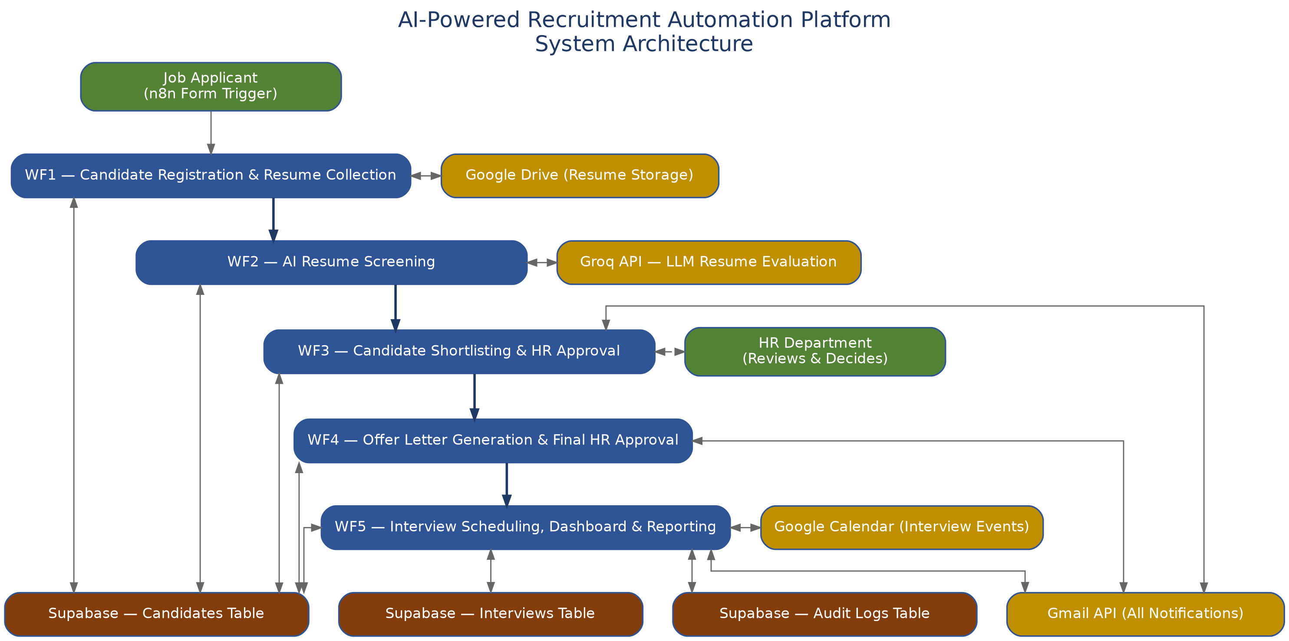
Figure 6 — Overall System Architecture: Presentation, Automation, Integration, and Data layers

7.2 Workflow Interaction Diagram
Unlike a monolithic application, the five workflows never call one another directly — n8n's "Execute Workflow" node is deliberately not used between them. Instead, every interaction between workflows happens indirectly, through reads and writes against the shared Supabase tables. Figure 8 makes this explicit: each workflow is shown writing a specific field or row when it completes its stage, and the next workflow in the chain is shown reading exactly that field or row as its starting condition. This is why the five workflows can be described as loosely coupled — WF2 does not need to know that WF1 exists, only that rows with a particular status are waiting in the Candidates table.
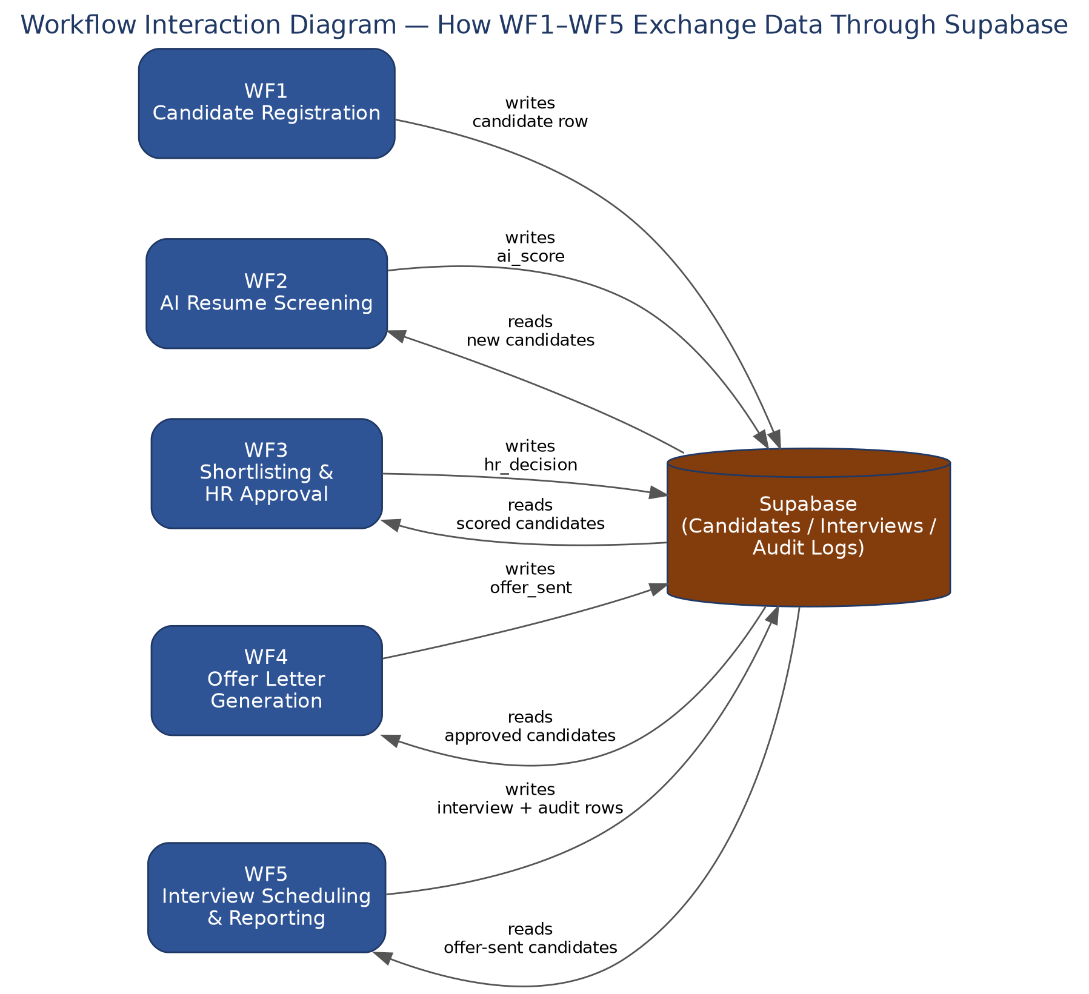
Figure 8 — Workflow Interaction Diagram: data exchanged between WF1–WF5 via Supabase
This indirect, database-mediated interaction pattern is what gives the platform its fault isolation and re-runnability, discussed further in Section 7.4: because no workflow holds a direct reference to another workflow's execution, any single workflow can be re-run, delayed, or temporarily disabled without breaking the others — they simply see fewer (or more) rows the next time they query Supabase.

7.3 Event Flow Between Workflows
While Section 7.2 shows what data moves between workflows, it does not show when. Figure 9 lays out the same five workflows on a timeline, showing the trigger type that starts each one and the event that makes the next workflow's input available. This distinguishes the three trigger models used across the platform: the form-driven, instant trigger of WF1; the recurring, batch-style Schedule Triggers of WF2 and WF3; and the deliberate, HR-initiated Manual Triggers of WF4 and WF5.
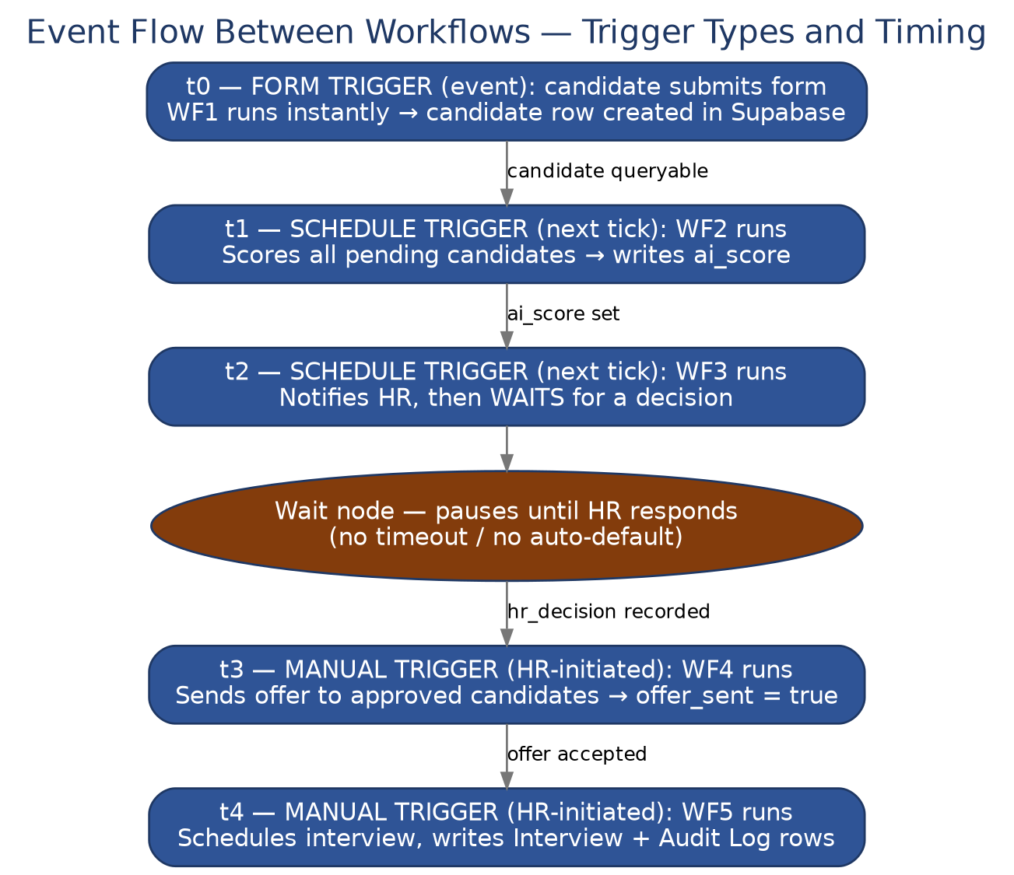
Figure 9 — Event Flow Between Workflows: trigger types and the timing of hand-offs between WF1–WF5
The Wait node inside WF3, shown in Figure 9 as a distinct pause in the timeline, is the one point in the entire pipeline where the platform's event flow depends on an external human action rather than a schedule or an API response. This is intentional: it is the mechanism that keeps the shortlisting decision in HR's hands, as described in Section 9.3, rather than allowing the pipeline to advance on a fixed timer regardless of whether HR has actually reviewed the candidate.

7.4 Fault Isolation and Idempotency
Because each workflow's state lives in Supabase rather than in the workflow's own execution memory, a failure partway through one workflow run does not corrupt or lose data from earlier stages. If Workflow 2 fails after scoring some candidates but before others, the next scheduled run simply picks up remaining candidates using its "Get many rows" filter, without re-processing candidates whose AI evaluation has already been written back. This gives the pipeline a natural degree of idempotency and resilience to transient failures such as a temporary Groq API timeout or a Google API rate limit.

8. Database Design (Supabase)
Three core tables underpin the platform: Candidates, Interviews, and Audit Logs. Together they provide a complete, queryable record of the recruitment lifecycle, and correspond directly to the Create/Get/Update row operations used throughout the five workflows. The schema is intentionally kept to three tables rather than a highly normalised multi-table design, since the volume and shape of recruitment data does not require it, and a simpler schema is easier for HR-facing reporting tools to query directly.

8.1 Candidates Table
The Candidates table is the anchor of the entire schema. Every other table refers back to it, and it accumulates data progressively as a candidate moves through the pipeline — starting with just registration details, and gaining an AI evaluation, an HR decision, and offer status as the workflows execute in sequence.
Field | Data Type | Constraint | Description
id | UUID / bigint | Primary Key | Unique candidate identifier
name | text | Not null | Applicant's full name
email | text | Not null, unique | Applicant's email address, used for all correspondence
position | text | Not null | Job role applied for
resume_file_id | text | — | Reference to the resume stored in Google Drive
ai_score | numeric | — | Score generated by the Groq LLM during resume evaluation
strengths | text | — | AI-generated summary of candidate strengths
weaknesses | text | — | AI-generated summary of candidate weaknesses
recommendations | text | — | AI recommendation on suitability
interview_date | timestamp | — | Scheduled interview date, once set
status | text | — | Current pipeline stage (e.g. New, AI Reviewed, Shortlisted, Approved, Rejected)
hr_decision | text | — | HR's shortlisting/approval decision
approved_by | text | — | HR user who made the decision
approval_time | timestamp | — | Time the decision was recorded
offer_sent | boolean | Default false | Whether the offer communication has been sent
offer_letter_url | text | — | Reference to the generated offer letter
offer_sent_date | timestamp | — | Date the offer was sent
created_at | timestamp | Default now() | Record creation timestamp

8.2 Interviews Table
The Interviews table is created only once an interview is actually scheduled, in Workflow 5. It is deliberately kept separate from the Candidates table, rather than storing interview details as columns on the candidate record, because a clean separation allows for the future possibility of multiple interview rounds per candidate (see Section 12) without altering the Candidates schema.
Field | Data Type | Constraint | Description
id | UUID / bigint | Primary Key | Unique interview record identifier
candidate_id | UUID / bigint | Foreign Key → Candidates.id | Links the interview to its candidate
interviewer_email | text | — | Assigned interviewer
interview_date | timestamp | — | Scheduled date and time
calendar_event_id | text | — | Reference to the created Google Calendar event
status | text | — | Interview status (Scheduled, Completed, Cancelled, etc.)
created_at | timestamp | Default now() | Record creation timestamp

8.3 Audit Logs Table
The Audit Logs table exists purely for traceability. Every one of the five workflows writes an entry here whenever it takes a significant action on a candidate record, creating a chronological history that the recruitment manager can query independently of the current state of the Candidates table. This is what allows the platform to answer questions such as "what happened to this candidate on this date" even after their status field has moved on to a later stage.
Field | Data Type | Constraint | Description
id | UUID / bigint | Primary Key | Unique log entry identifier
candidate_id | UUID / bigint | Foreign Key → Candidates.id | Candidate the action relates to
workflow_name | text | — | Which of the five workflows performed the action
action | text | — | The specific action taken (e.g. 'AI Screening Completed')
status | text | — | Outcome of the action (Success / Failure)
details | text | — | Additional context, such as error messages or field values
created_at | timestamp | Default now() | Record creation timestamp

8.4 Entity-Relationship Diagram
Figure 7 shows the relationships between the three tables. Candidates is the parent entity; Interviews and Audit Logs each hold a foreign key (candidate_id) back to Candidates, forming two one-to-many relationships — a single candidate may have many interview records over time (see Section 12.2) and will typically accumulate many audit log entries as they progress through the pipeline.
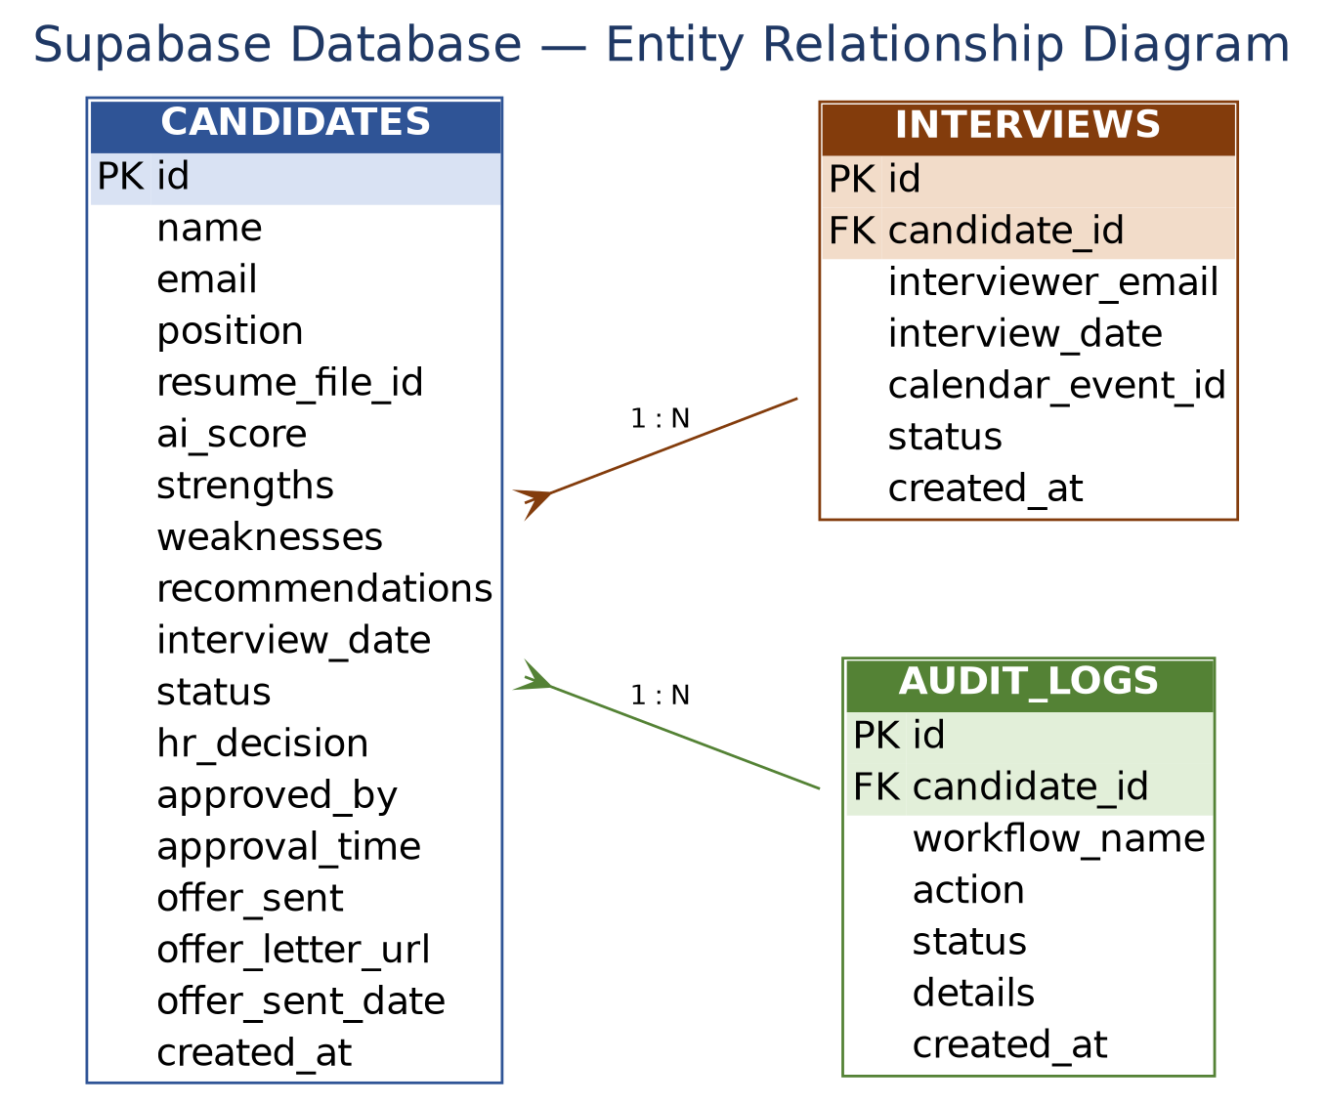
Figure 7 — Entity-Relationship Diagram: Candidates, Interviews, and Audit Logs

8.5 Relationships and Referential Integrity
Both the Interviews and Audit Logs tables reference Candidates.id through a candidate_id foreign key. This design means that no interview or audit record can exist without a corresponding candidate, which keeps the dataset consistent and makes it straightforward to reconstruct a candidate's entire history with a single join. In a production deployment, these foreign keys would typically be enforced at the database level with ON DELETE restrictions or cascades, and indexed on candidate_id to keep the frequent "Get many rows" lookups performed by the n8n workflows fast even as the Candidates table grows.

8.6 Why a Relational Schema
A relational schema was chosen over a document-style or flat spreadsheet-like store because the recruitment domain has clear, stable relationships (one candidate to many interviews, one candidate to many audit entries) and because n8n's Supabase node maps naturally onto simple row-based Get/Create/Update operations. This also means the same data can be queried directly with SQL for ad-hoc reporting, without needing to build a separate analytics pipeline.

9. How the Workflows Work
Each stage of the recruitment lifecycle is implemented as an independent n8n workflow, connected through the shared Supabase database. The subsections below are supported by screenshots taken directly from the live n8n editor for each of the five workflows, followed by a step-by-step explanation of the nodes and logic used, and a short discussion of error handling and edge cases for that stage.

9.1 WF1 — Candidate Registration & Resume Collection
Trigger: n8n Form Trigger ("on form") — fires when a candidate submits the registration form and resume
Goal: Turn a raw form submission into a validated, stored candidate record
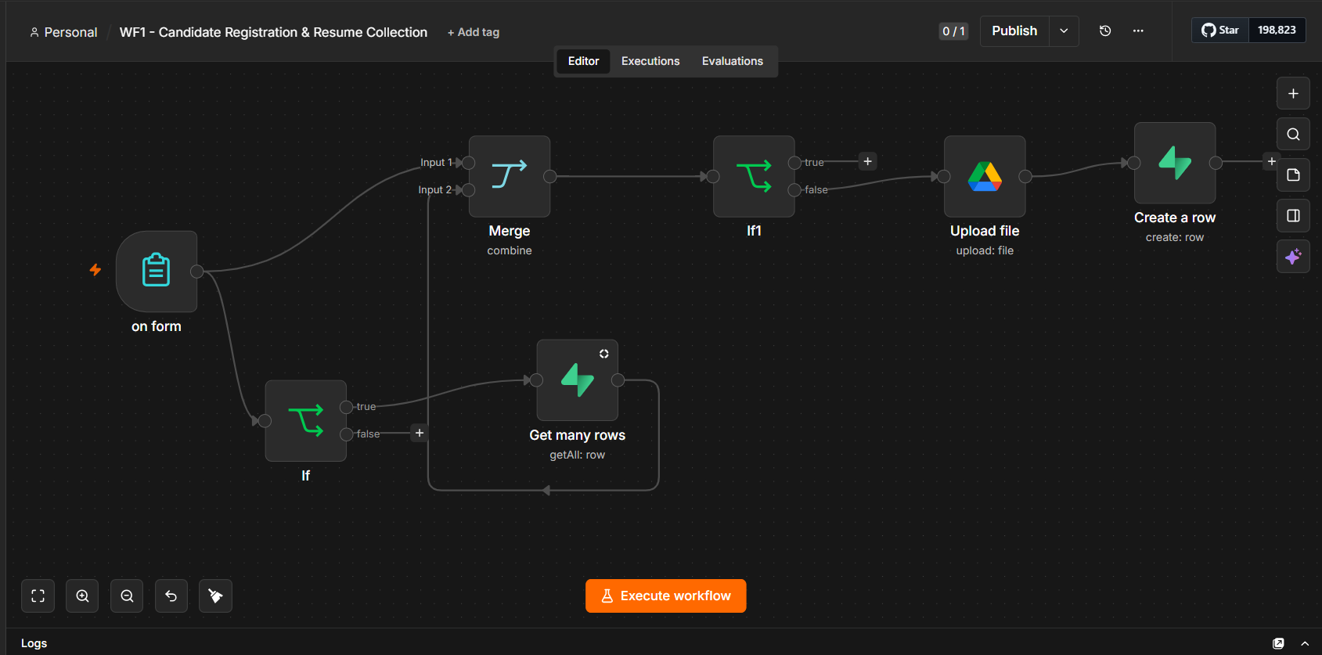
Figure 1 — WF1: Candidate Registration & Resume Collection (n8n canvas)
- The "on form" trigger fires when a candidate submits the registration form, including their resume.
- The submission is checked against existing data: an If node evaluates the incoming record and, on its true branch, queries Supabase ("Get many rows") to look up matching candidates.
- A Merge node combines the original form submission with the result of that lookup.
- A second condition ("If1") evaluates the merged data to confirm the submission should proceed.
- On the true branch, an "Upload file" node stores the candidate's resume in Google Drive.
- A "Create a row" node then writes a new candidate record into the Supabase Candidates table, referencing the uploaded resume.

Design Notes: Duplicate Handling
The duplicate check in steps 2–4 exists to prevent the same applicant from creating multiple candidate records if they submit the form more than once — for example, after refreshing the page or resubmitting after a network error. Rather than silently rejecting a resubmission, the workflow evaluates the merged result and only proceeds to create a new record on the branch where no conflicting record was found, keeping the Candidates table free of duplicate rows for the same applicant and role.

9.2 Workflow 2 — AI Resume Screening
Trigger: Schedule Trigger — runs automatically at a fixed interval
Goal: Produce a consistent, AI-generated evaluation for every candidate
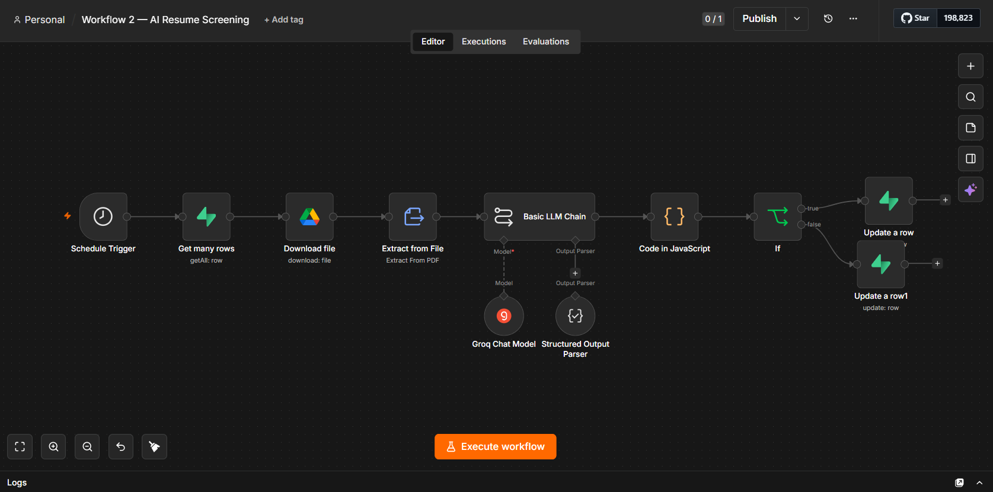
Figure 2 — Workflow 2: AI Resume Screening (n8n canvas)
- A Schedule Trigger starts the workflow on a recurring basis.
- "Get many rows" retrieves candidate records from Supabase.
- "Download file" retrieves the corresponding resume from Google Drive.
- "Extract from File" (Extract From PDF) converts the resume into plain text.
- The extracted text is passed into a Basic LLM Chain, which calls the Groq Chat Model together with a Structured Output Parser that forces the response into a fixed schema (score, strengths, weaknesses, recommendation).
- A "Code in JavaScript" node processes and reformats the parsed AI output.
- An If node checks the result and routes to one of two "Update a row" nodes, writing the AI evaluation back to the correct candidate record in Supabase.

Design Notes: Why a Structured Output Parser
Large language models produce free-form text by default, which is difficult to store reliably in fixed database columns. The Structured Output Parser node solves this by supplying the LLM with a strict output schema; if the model's raw response does not conform, n8n can catch and retry the call rather than writing malformed data into Supabase. This is what allows step 7's branching If node to reliably distinguish a well-formed evaluation from one that needs to be reprocessed, and is central to the platform's goal of consistent, bias-reduced evaluation described in Section 4.

Design Notes: Batch Scheduling
Running Workflow 2 on a Schedule Trigger rather than immediately after each registration allows resumes to be processed in batches, which is more efficient when calling an external LLM API and gives the workflow natural resilience — if the Groq API is briefly unavailable, the next scheduled run will simply pick up any candidates still awaiting evaluation.

9.3 Workflow 3 — Candidate Shortlisting & HR Approval
Trigger: Schedule Trigger — runs automatically at a fixed interval
Goal: Notify HR of shortlisted candidates and capture the approval decision
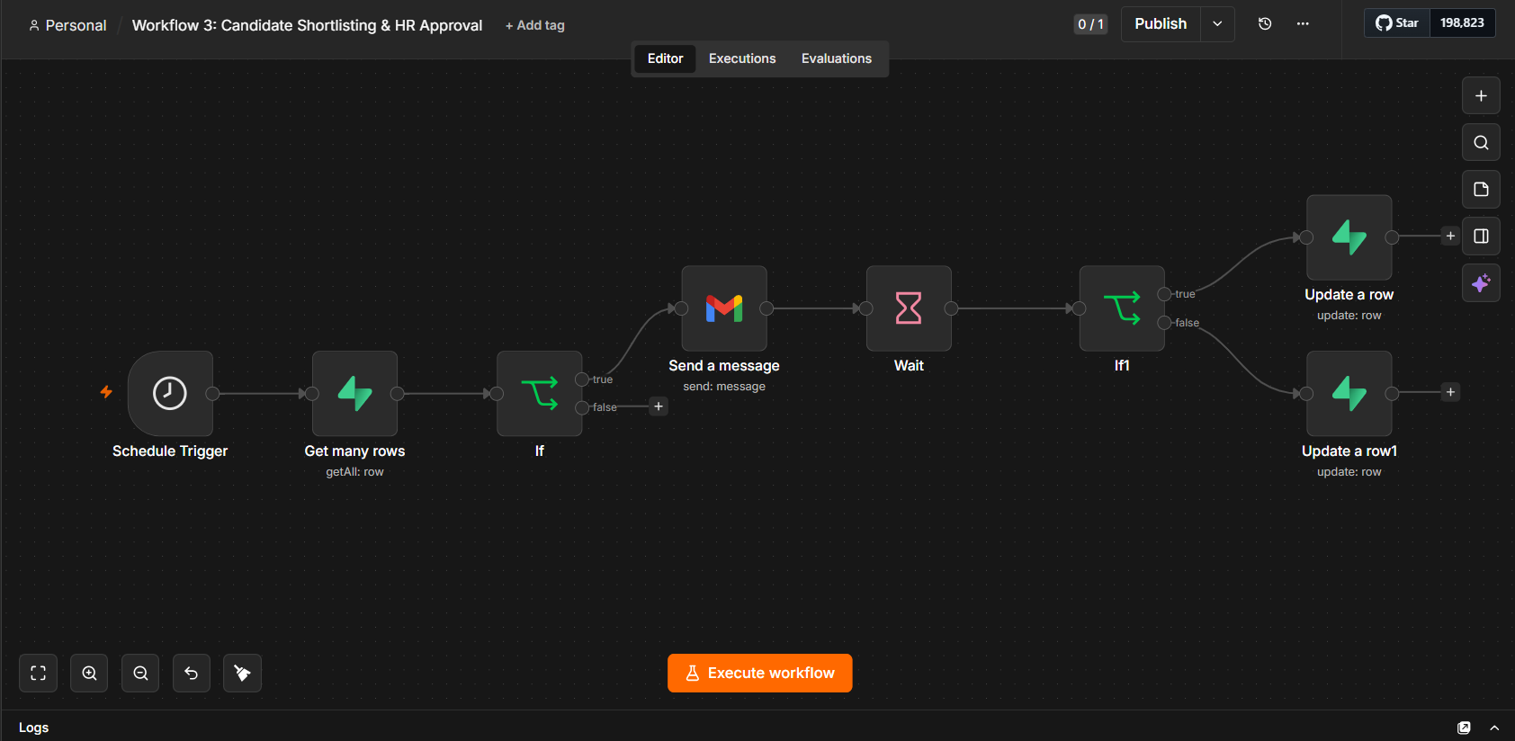
Figure 3 — Workflow 3: Candidate Shortlisting & HR Approval (n8n canvas)
- A Schedule Trigger starts the workflow, which retrieves candidate records from Supabase via "Get many rows".
- An If node filters which candidates should proceed — for example, those that meet the AI shortlisting criteria.
- On the true branch, a "Send a message" (Gmail) node emails the relevant recipient with the candidate details.
- A Wait node pauses the workflow to allow time for a decision.
- A second condition ("If1") checks the outcome and branches into one of two "Update a row" nodes, updating the candidate's status in Supabase to reflect the shortlisting/approval decision.

Design Notes: The Wait Node and Human-in-the-Loop Design
The Wait node in step 4 is the clearest expression of the platform's human-in-the-loop philosophy: the workflow does not attempt to guess or infer HR's decision, and it does not time out into an automatic default. It pauses execution and only proceeds once a response has been captured, ensuring that every shortlisting outcome reflects an actual HR judgement rather than a system default. This directly supports the objective, described in Section 5, of keeping HR in control of every decision that affects a candidate's outcome.

9.4 Workflow 4 — Offer Letter Generation & Final HR Approval
Trigger: Manual trigger ("When clicking 'Execute workflow'")
Goal: Send the offer communication to approved candidates
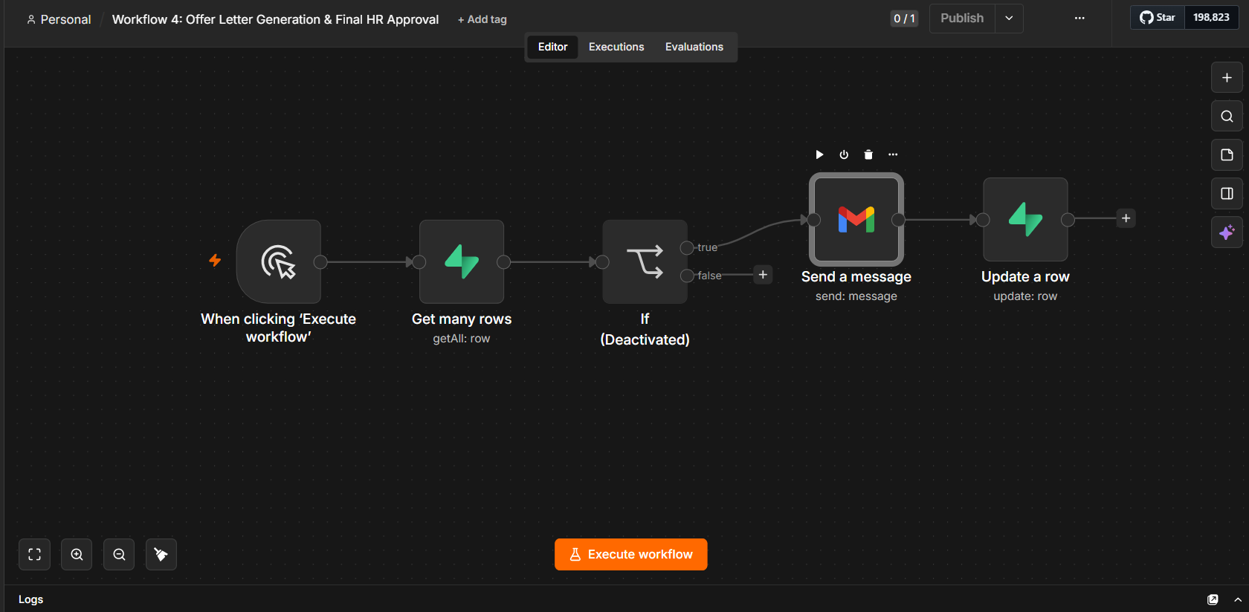
Figure 4 — Workflow 4: Offer Letter Generation & Final HR Approval (n8n canvas)
- The workflow is run on demand by HR via the manual trigger.
- "Get many rows" retrieves the relevant candidates from Supabase.
- An If node is present to filter eligible candidates; in the current version of this workflow it is deactivated, so every retrieved row passes through.
- "Send a message" (Gmail) sends the offer communication to the candidate.
- "Update a row" updates the candidate's Supabase record, for example marking the offer as sent.

Design Notes: Manual Trigger for Offer Communication
Unlike Workflows 2 and 3, Workflow 4 is deliberately triggered manually rather than on a schedule. Sending an offer is a consequential, often legally significant communication, and HR typically wants to review the final candidate list and choose the moment of dispatch rather than having offers go out automatically on a timer. The currently deactivated filter If node in step 3 is a placeholder for future eligibility rules — such as budget headcount checks — that can be re-enabled without redesigning the workflow, as discussed in Section 12.

9.5 Workflow 5 — Recruitment Dashboard & Daily HR Report
Trigger: Manual trigger ("When clicking 'Execute workflow'")
Goal: Schedule interviews on Google Calendar and keep the recruitment records up to date
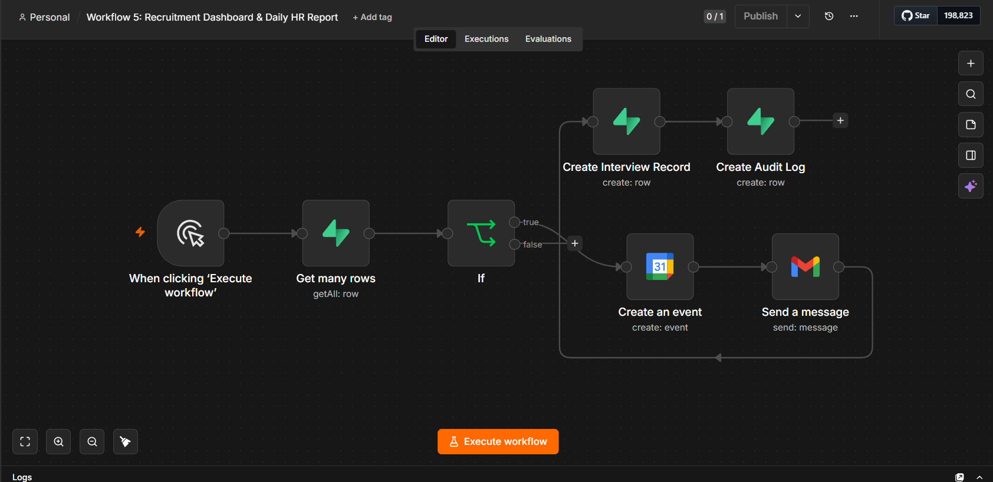
Figure 5 — Workflow 5: Recruitment Dashboard & Daily HR Report (n8n canvas)
- The workflow is run on demand and retrieves candidate records from Supabase via "Get many rows".
- An If node branches the flow depending on whether a calendar invite has already been created for the candidate.
- On one branch, a "Create an event" (Google Calendar) node books the interview slot, and "Send a message" (Gmail) emails the candidate the interview details.
- Both branches converge on "Create Interview Record", which writes a new row into the Supabase Interviews table.
- Finally, "Create Audit Log" writes a corresponding entry into the Supabase Audit Logs table, giving the recruitment manager a consolidated, traceable record of the run.

Design Notes: Convergent Branching
The branch-and-converge pattern in steps 2–4 ensures that whether or not a new calendar event needed to be created, every candidate processed by this run ends up with a matching Interviews row and an Audit Logs entry. This guarantees the two downstream tables never fall out of sync with each other, regardless of which branch a given candidate followed.

9.6 Cross-Workflow Summary
Although each workflow is described individually above, they form a single logical pipeline connected purely through Supabase state rather than direct workflow-to-workflow calls. The table below summarises the trigger type, primary Supabase operations, and external systems touched by each workflow, making the differences and dependencies between them easy to compare at a glance.
Workflow | Trigger Type | Primary Supabase Operations | External Systems
WF1 | Form Trigger | Get many rows, Create a row | Google Drive
WF2 | Schedule Trigger | Get many rows, Update a row | Google Drive, Groq API
WF3 | Schedule Trigger | Get many rows, Update a row | Gmail
WF4 | Manual Trigger | Get many rows, Update a row | Gmail
WF5 | Manual Trigger | Get many rows, Create a row (×2) | Google Calendar, Gmail

10. Key Features
- AI-driven resume screening: every resume is analysed by a Groq-hosted LLM with structured, schema-enforced output, so scoring criteria never vary between candidates.
- Native n8n web form: candidate registration and resume upload happen through a single hosted form, with duplicate-record checks before insert.
- Google Drive integration: resume storage and retrieval is handled automatically, with only a lightweight reference stored in the database.
- Automated shortlisting and HR approval: Gmail notifications with wait-and-check logic keep a human decision-maker in the loop without requiring HR to poll the system.
- Automated, on-demand offer letter delivery: offers are sent the moment HR chooses to run Workflow 4, with the Supabase record updated in the same run.
- Automated interview scheduling: Google Calendar events are created directly from candidate data, removing manual back-and-forth entirely.
- Centralized Supabase database: a single source of truth for candidate, interview, and audit data, queryable directly for reporting.
- End-to-end audit logging: every recruitment action across all five workflows is recorded, giving full traceability of the pipeline.
- Fully automated, event-driven pipeline: built entirely on n8n, using a consistent, visual node-based approach across all five workflows.

10.1 Feature-to-Objective Traceability
Each feature above maps directly back to one or more of the project objectives set out in Section 5. AI-driven screening and the Structured Output Parser satisfy the objective of consistent, bias-reduced evaluation; the Gmail and Google Calendar integrations satisfy the objectives around automated communication and scheduling; and the centralized Supabase schema with audit logging satisfies the objective of maintaining a complete, traceable recruitment record. This traceability is what allows the platform's design to be evaluated against its original goals rather than judged only on the features it happens to include.

11. Expected Outcomes
- Reduced overall recruitment turnaround time, since resume screening, shortlisting notification, and interview scheduling no longer wait on manual HR bandwidth.
- Consistent, bias-reduced candidate evaluation, since every resume is scored against the same schema-enforced criteria by the same LLM configuration.
- Lower manual workload for HR staff, who shift from performing repetitive data entry and first-pass screening to reviewing AI-generated recommendations and making decisions.
- Faster interview scheduling with fewer coordination delays, since Google Calendar events are created directly from the workflow rather than through email negotiation.
- A centralized, auditable recruitment record, allowing the recruitment manager to answer status and history questions from Supabase directly rather than searching email threads.
- A more transparent and predictable candidate experience, since applicants receive timely, consistent automated updates at each stage of the process.

11.1 How Outcomes Will Be Observed
Because the underlying pipeline is fully data-driven, each of the outcomes above can, in principle, be observed directly from the Supabase schema rather than relying on anecdotal impressions. Turnaround time can be measured as the interval between a candidate's created_at timestamp and their final status update; HR workload reduction can be inferred from the volume of candidates processed per workflow run relative to prior manual throughput; and evaluation consistency can be checked by confirming that ai_score values are populated for every candidate and fall within the expected schema-enforced range. This ties the qualitative benefits described above to concrete fields already present in the database design in Section 8, making the platform's impact measurable rather than purely assumed.

12. Future Enhancements
- A resume ranking dashboard for recruiters: a lightweight front-end (or Supabase-native dashboard) surfacing candidates sorted by ai_score, status, and role, so recruiters do not need to query the database directly.
- Support for multi-interviewer panel scheduling: extending the Interviews table and Workflow 5 to create multiple Google Calendar events and interviewer_email entries per candidate for panel-style interviews.
- AI-generated, role-specific interview questions: extending the Groq-based LLM chain in Workflow 2 to also propose tailored interview questions based on a candidate's resume and the target role.
- Automated candidate skill matching against job requirements: enriching the Structured Output Parser schema with explicit skill-tagging, so candidates can be matched and filtered against structured job requirement profiles rather than a single overall score.
- A recruitment analytics dashboard built on Supabase data: aggregate reporting on time-to-hire, pipeline conversion rates, and source-of-hire, drawing directly on the Candidates, Interviews, and Audit Logs tables.
- WhatsApp/SMS notification channels: adding alternative notification nodes alongside Gmail for candidates who prefer or more reliably respond to messaging apps or SMS.
- Automated background verification: integrating a background-check API as a new stage after offer acceptance, with its own status fields and audit trail.
- Structured interview feedback collection: adding a feedback form and a corresponding workflow stage so interviewers can record post-interview evaluations directly into Supabase, closing the loop between Workflow 5 and the final hiring decision.
- Additional intake channels (LinkedIn, Google Forms, employee referrals): extending Workflow 1 to accept submissions from these sources in addition to the native n8n form, using the existing duplicate-check logic to merge them into the same Candidates table.
- Integration with LinkedIn and external job portals: extending candidate intake beyond the native n8n form to ingest applications sourced from external job boards.

12.1 Prioritisation Considerations
Not all of the enhancements above carry equal implementation cost or equal expected benefit. The resume ranking dashboard and the recruitment analytics dashboard are largely read-only additions on top of the existing Supabase schema and would require no changes to the five existing workflows, making them comparatively low-effort, high-visibility candidates for a first phase of enhancement. Multi-interviewer panel scheduling and background verification, by contrast, require schema changes (new tables or additional columns) and new workflow branches, and would be better suited to a later phase once the core pipeline has been validated in production.

12.2 Schema Evolution for Panel Interviews
As noted in Section 8.2, the Interviews table was deliberately kept as a separate table from Candidates rather than storing interview fields directly on the candidate record. This means supporting multiple interview rounds per candidate — the most structurally significant enhancement on the roadmap — would only require inserting multiple rows into the existing Interviews table (one per round or panel member) rather than redesigning the schema, since the one-to-many relationship shown in Figure 7 already supports this pattern.

13. Conclusion
This platform automates the complete recruitment lifecycle — registration, AI-driven resume screening, shortlisting, HR approval, offer generation, and interview scheduling — using n8n as the orchestration layer, Supabase as the system of record, Groq for AI evaluation, and Gmail/Google Calendar for communication and scheduling. By replacing manual, email-driven steps with a connected and auditable pipeline of five workflows, the system reduces recruiter workload, standardizes candidate evaluation, and gives the organization a faster, more transparent hiring process.
The architecture and database design described in Sections 7 and 8 show that this automation was achieved without sacrificing the human oversight that recruitment decisions require: every point at which a candidate's outcome is materially affected — shortlisting, final approval, and offer dispatch — still requires an explicit HR action, captured and preserved permanently in the Audit Logs table. The platform therefore automates the administrative burden of recruitment while leaving the judgement of recruitment firmly in human hands.
Taken as a whole, the five interconnected n8n workflows, the three-table Supabase schema, and the surrounding integrations with Google Drive, Groq, Gmail, and Google Calendar demonstrate that a modern, low-code automation stack can deliver much of the benefit typically associated with a full commercial Applicant Tracking System — consistent evaluation, centralized records, and automated communication — while remaining transparent, inspectable, and extensible enough for the enhancements outlined in Section 12 to be added incrementally as the organization's recruitment needs grow.

14. References
The following tools, platforms, and API documentation were referenced during the design and implementation of this platform:
- n8n Documentation — Workflow automation platform, node reference, and trigger types (n8n.io)
- Supabase Documentation — Database, REST API, and client libraries (supabase.com)
- Groq API Documentation — Large language model inference API (groq.com)
- Google Workspace APIs — Gmail API, Google Drive API, and Google Calendar API reference documentation (developers.google.com)
- n8n LangChain Integration Docs — Basic LLM Chain and Structured Output Parser nodes (docs.n8n.io)

